Ciencias Naturales
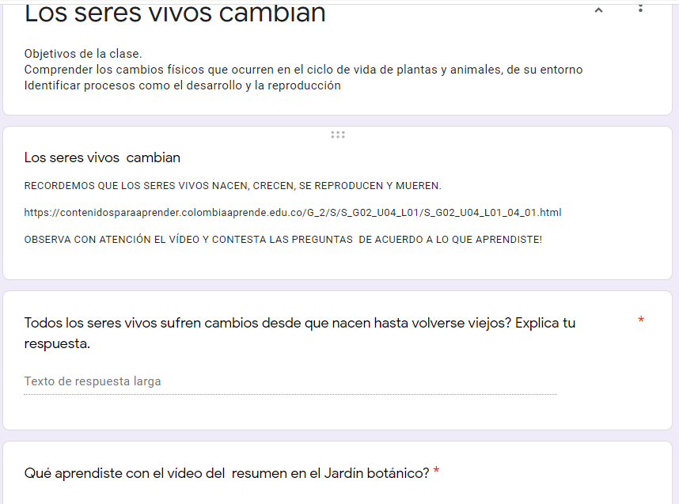

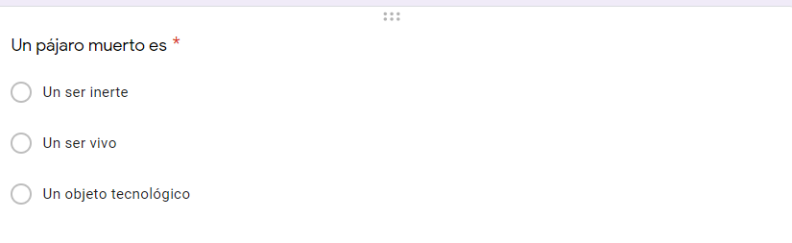

ETICA Y VALORES

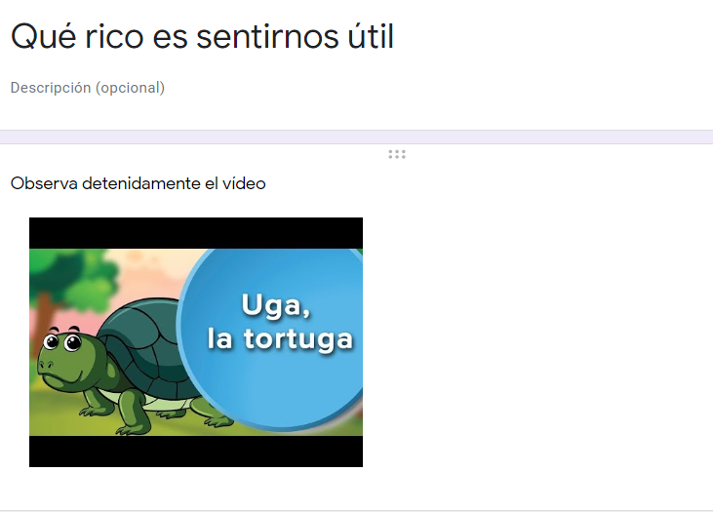
https://www.google.com/search?q=uga+la+tortuga+video&rlz=1C1NHXL_esCO682CO682&oq=uga+la&aqs=chrome.4.0j69i57j0l6.6762j0j7&sourceid=chrome&ie=UTF-8
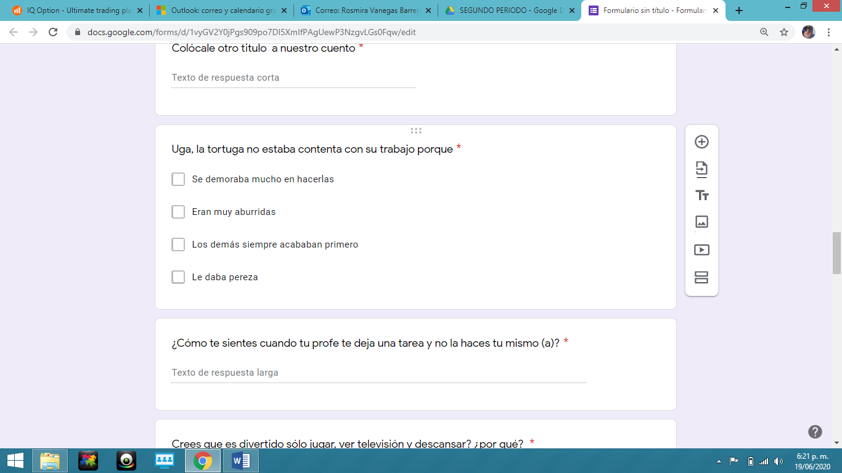
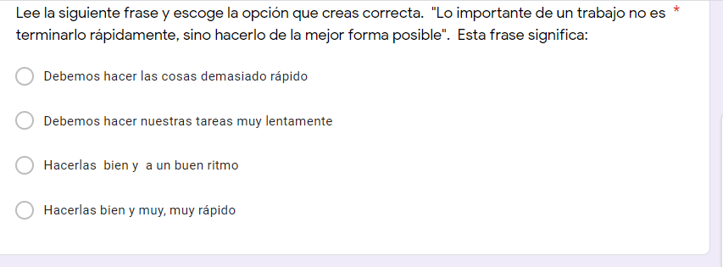
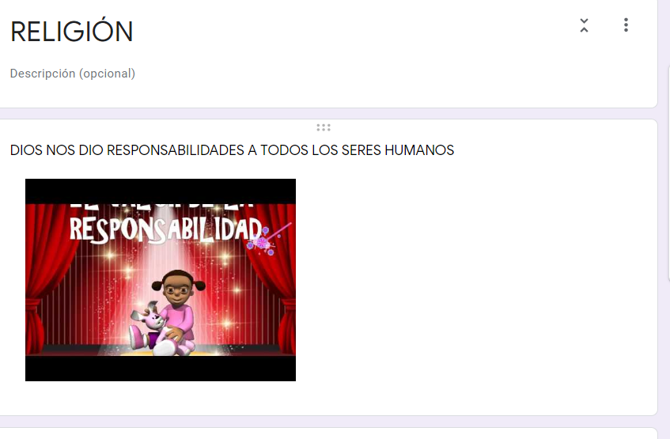
https://www.youtube.com/watch?v=LpxcKXov-f0
